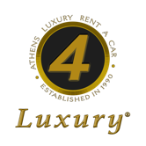
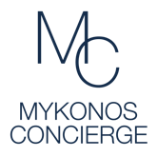
ATHENS LUXURY CARS | MYKONOS CONCIERGE ® GROUP

EXPRESS CHECK-IN FORM

When we confirm your reservation, in order to have no delay upon your arrival and to collect your car immediately we offer you the service EXPRESS CHECK-IN.
You may send us your personal details, like your passport number and your driver's license number in order to prepare the contract of the rental before your arrival.
The contract will be ready, you just need to sign and you may leave for your holidays.
We kindly ask you to:

PRINT THIS EXPRESS CHECK-IN FORM,
FILL IN THE FOLLOWING PERSONAL DETAILS AND THEN,
FAX THE DATA TO OUR OFFICE. FAX NO.: (0030) 210 300 8913

Renter's Name:
Passport No:
Passport Date Issued:
Passport Issued Place:
Driver's License No:
License Date Issued:
License Issued Place:
License Date Expires:
Date of Rental
Booking ID
(if you know or you can find it into notification email that you received)

DATE: _____/_____/_________ ___________________________
(signature)

